Instruções para Preparação da Apresentação do Projeto da Disciplina Aplicações de DSP em Formato Duas Colunas

Fulano Harashima | Beltrano M. Wilamowski
Kyoto Institute of Technology | College of Engineering
Asahigaoka 6-6 Hino | University of Sylicon
Sapporo 191-0065 | 800 Park, Blvd.
JAPAN | Boise, ID 83712, USA
fu.harashima@ieee.org | bmwilam@ieee.org

Abstract – Instructions providing basic guidelines for preparing camera-ready (CR) proceedings-styled papers for the ADSP course. This document is itself an example of the desired layout for CR papers (inclusive of this abstract). The document contains information regarding desktop publishing format, type sizes, and type faces. Style rules are provided that explain how to handle equations, units, figures, tables, references, abbreviations, and acronyms. Sections are also devoted to the preparation of the references and acknowledgements.

I. introduction

Your goal is to simulate, as closely as possible, the usual appearance of typeset papers. This document provides an example of the desired layout and contains information regarding desktop publishing format, type sizes and typefaces.

A. Full-Size Camera-Ready (CR) Copy

If you have desktop publishing facilities, (the use of a computer to aid in the assembly of words and illustrations on pages) prepare your CR paper in full-size format, on letter size paper 21.5 x 28.0 cm (8.5 x 11 inch). It must be output on a printer (e.g., laser printer) having 300 d.p.i., or better, resolution. Laser quality printers, such as dot matrix printers, are not acceptable, as the manuscript will not reproduce the desired quality.
1) Typefaces and Sizes: There are many different typefaces and a large variety of fonts (a complete set of characters in the same typeface, style, and size). Please use a proportional serif typeface such as Times Roman or Dutch. If these are not available to you, use the closest typeface you can. The minimum type size for the body of the text is 10 point. The minimum size for applications like table captions, footnotes, and text subscripts is 8 point As an aid to gauging type size, 1 point is about 0.35 mm (1/72 in). Try to follow the type sizes specified in Table I. Examples are as follows:

This is similar to Times Roman 8 point normal
This is similar to Times Roman 9 point bold
This is similar to Times Roman 10 point normal
This is similar to Times Roman 12 point normal
This is similar to Times Roman 14 point bold

2) Format: In formatting your original letter size page, set top and bottom margins to 20 mm (0.8 in or 5 picas) and left and right margins to about 18 mm (0.7 in or 4 picas). The space between the two columns is 6 mm (0.25 in or 1 pica). Paragraph indentation is about 3.5 mm (0.15 in or 1 pica). Left- and right-justify your columns. Use either one or two spaces between sections, and between text and tables or figures, to adjust the column length. On the last page of your paper, try to adjust the lengths of the two columns so that they are the same. Use automatic hyphenation and check spelling. Either digitize or paste down your figures.
3) Number of pages: The maximum number of pages per paper is 6. Do not number your pages.

II. UNITS

Metric units are preferred for use in IEEE publications in light of their international readership and the inherent convenience of these units in many fields. In particular, the use of the International System of Units (SI Units) is advocated. This system includes a subsystem the MKSA units, which are based on the meter, kilogram, second, and ampere. British units may be used as secondary units (in parentheses). An exception is when British units are used as identifiers in trade, such as, 3.5 inch disk drive.

TABLE I
TYPE SIZES FOR CAMERA-READY PAPERS

Type Appearance
size Regular Bold Italic

8 Table captionsª ,
tables, table namesª ,
first letters in table captionsª ,
figure captions, footnotes
9 Abstract email
10 Authors' affiliations, main Subheadings
text, equations, section titlesª
12 Authors' names
14 Paper title
ªUppercase
III. ADDITIONAL REQUIREMENTS

A. Figures and Tables

Position figures and tables at the tops and bottoms of columns. Avoid placing them in the middle of columns. Large figures and tables may span across both columns. Figure captions should be below the figures; table captions should be above the tables. Avoid placing figures and tables before their first mention in the text Use the abbreviation "Fig. 1," even at the beginning of a sentence.
Figure axis labels are often a source of confusion. Try to use words rather than symbols. As an example, write the quantity "Magnetization," or Magnetization, M," not just "M." Put units in parentheses. Do not label axes only with units. In the example, write "Magnetization (kA/m)" or "Magnetization (kA·m^{-l}),'' not just "kA/m." Do not label axes with a ratio of quantities and units. For example, write "Temperature (K)," not "Temperature/K."

B. Numbering

Number reference citations consecutively in square brackets [1]. The sentence punctuation follows the brackets [2]. Refer simply to the reference number, as in [3]. Do not use "Ref. [3]" or "reference [3]".
Number footnotes separately in superscripts¹. Place the actual footnote at the bottom of the column in which it is cited. Do not put footnotes in the reference list. Use letters for table footnotes (see Table I).

C. Abbreviations and Acronyms

Define abbreviations and acronyms the first time they are used in the text, even after they have been defined in the abstract. Abbreviations such as IEEE, SI, MKS, CGS, ac, dc, and rms do not have to be defined. Do not use abbreviations in the title unless they are unavoidable (for example, the title of this article).

D. Equations

Number equations consecutively with equation numbers in parentheses flush with the right margin, as in (1). To make your equations more compact, you may use the solidus (/), the exp. function, or appropriate exponents. Italicise Roman symbols for quantities and variables, but not Greek symbols. Use a long dash rather than a hyphen for a minus sign. Use parentheses to avoid ambiguities in the denominator. Punctuate equations with commas or periods when they are part of a sentence:
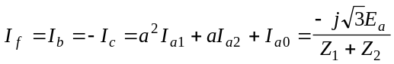 (1)
where I_{f} is the fault current at the terminals of an unloaded wye connected generator, for a line-to-line fault using positive, negative and zero sequence voltages, currents, and impedances.
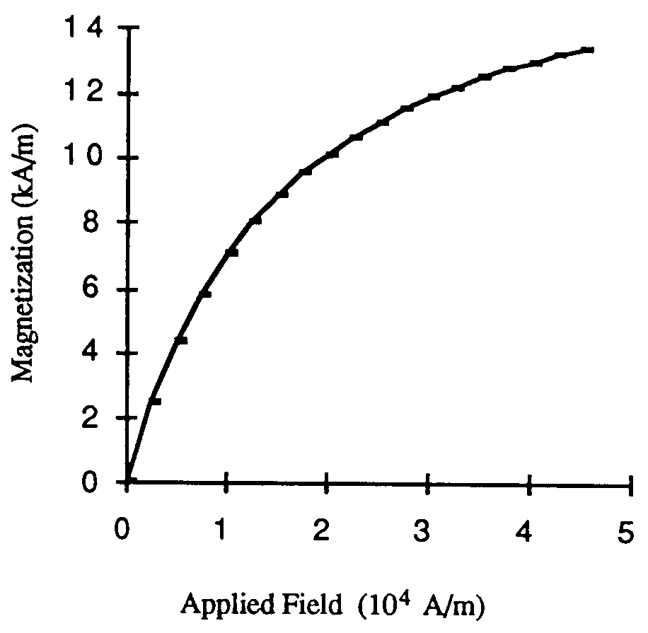
Fig. 1. Magnetization as a function of applied field. Note how the caption is centred in the column

Be sure that the symbols in your equation have been defined before the equation appears or immediately following. Use "(1)," not "Eq. (l)" or "equation (1)," except at the beginning of a sentence: "Equation (l) is ..."

IV. ACKNOWLEDGMENT

The authors gratefully acknowledge the contributions of Ian X. Austan, Ann Burgmeyer, C.J. Essel, and S. H. Gold.

V. REFERENCES

References are important to the reader; therefore, each citation must be complete and correct. If at all possible, references should be commonly available publications.

For a paper citation:

[l] J.S. Hunter and J.C. Hung, "Development of low-cost Multifunction sensors for lightweight fire and forget antitank weapon system," IEEE Trans. Industrial Electronics, vol. E-30, no. 1, Feb. 1983, pp. 7-10.

For a book citation:

[2] G.K. Dubey, Power Semiconductor Controlled Drives, Englewood Cliffs, NJ: 1989, p. 81.

For a conference citation:

[3] L. Alqueres and J. C. Praca, "The Brazilian power system and the challenge of the Amazon transmission," in Proceedings of the 1991 Power Engineering Society Transmission and Distribution Conference, 91CH3070-0, pp. 315-320.

Formato usualmente requerido para publicação de trabalhos em anais de conferências do IEEE.

